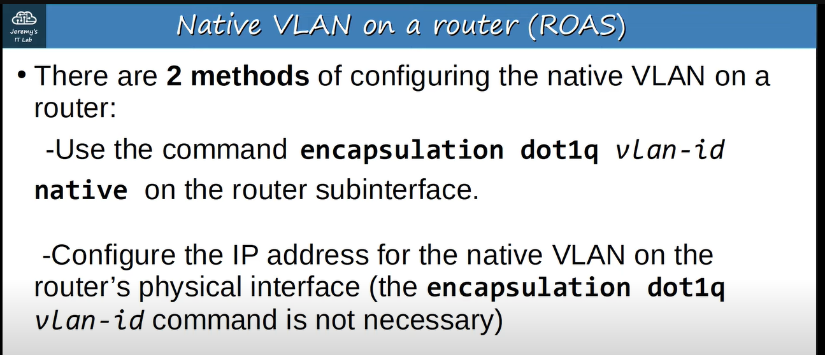

**First we will use method-1**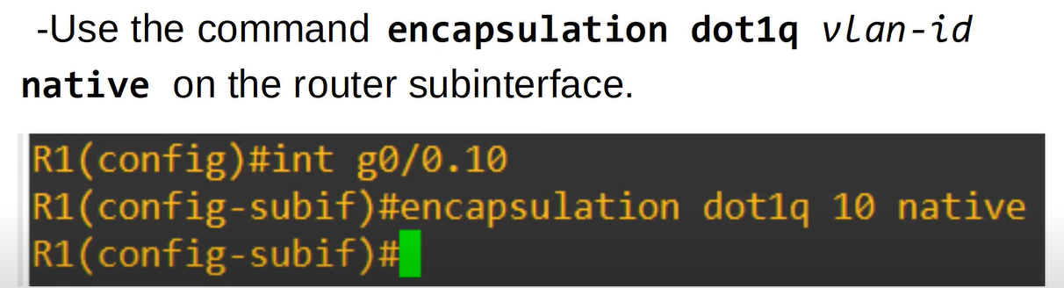

**We will use wire-shark to capture the ICMP request from 192.168.1.65 to 192.168.1.1** 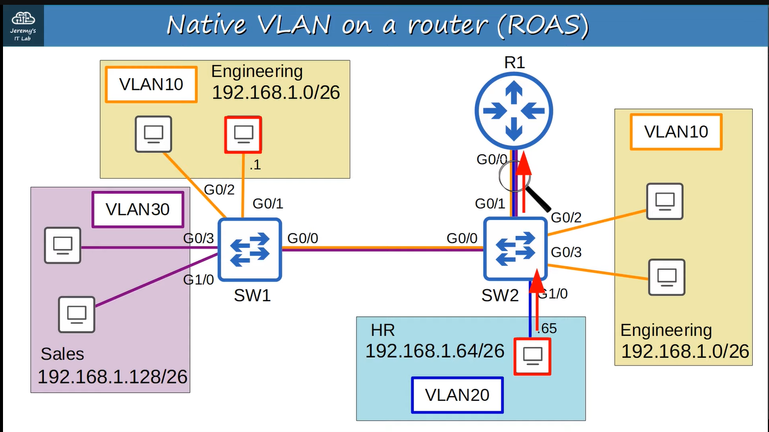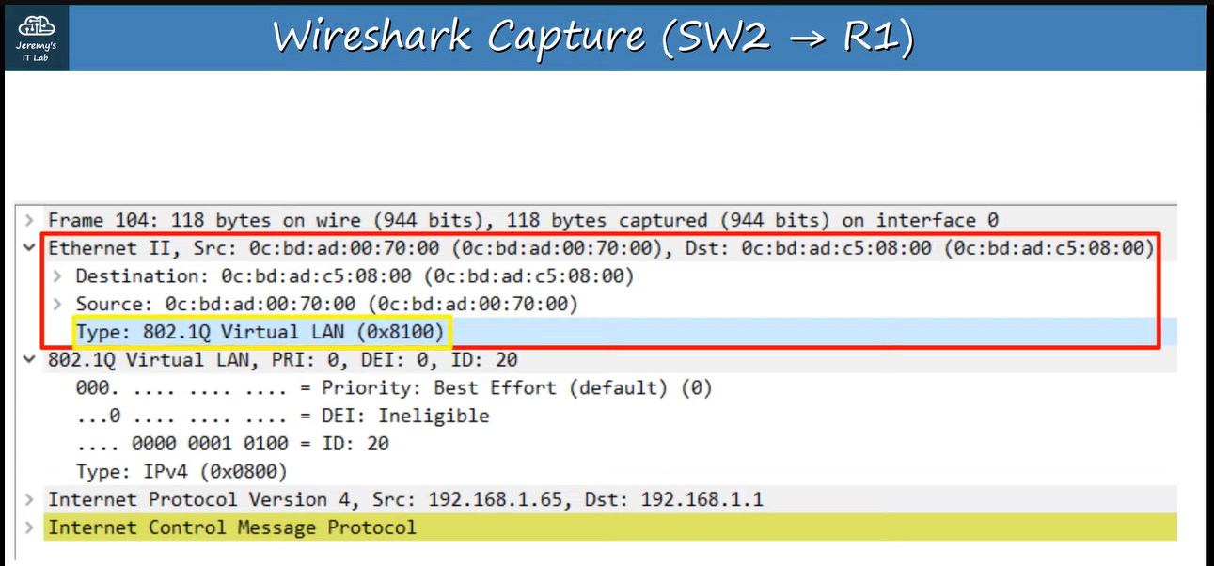

**When R1 will send to SW2 that ICMP request to forward it to the 192.168.1.1 then R1 will not tag it as VLAN10, because, we have configured it as native-VLAN on router ↓**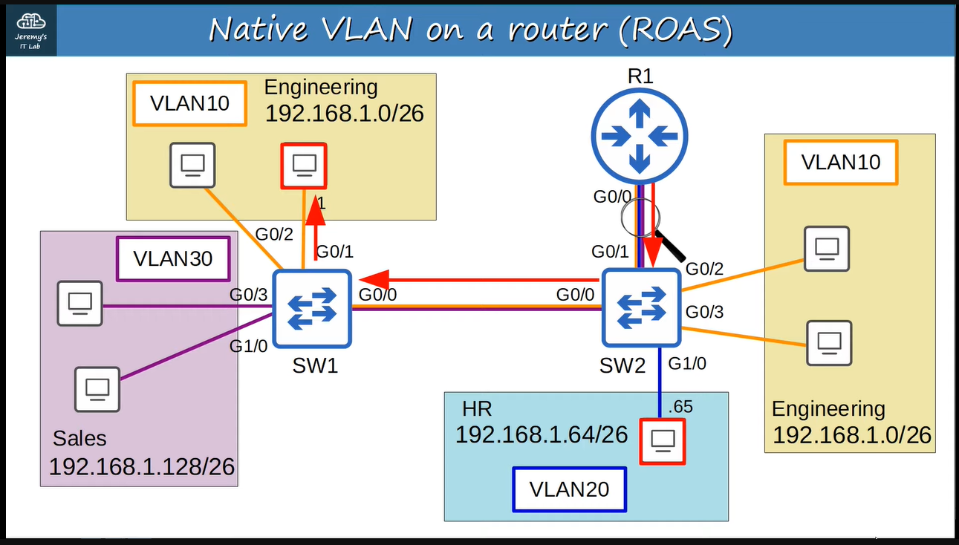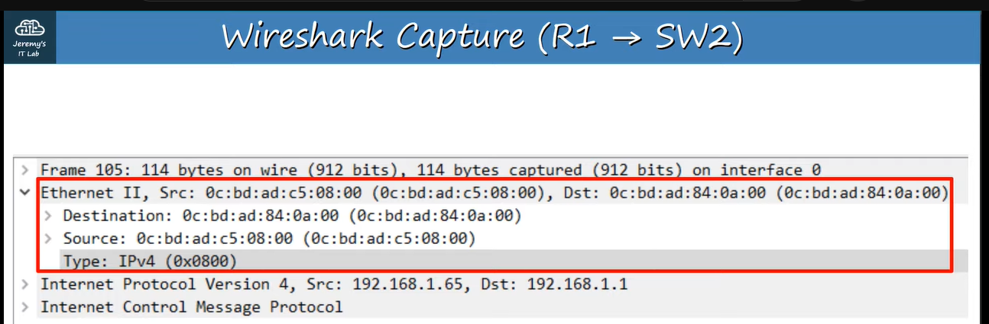

**Now we will use method-2** 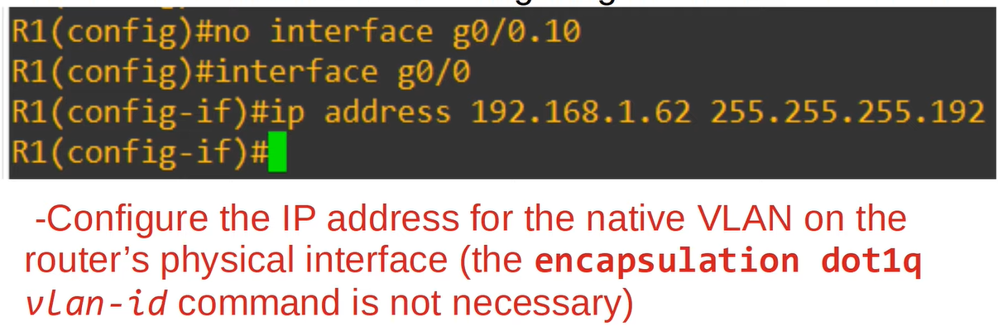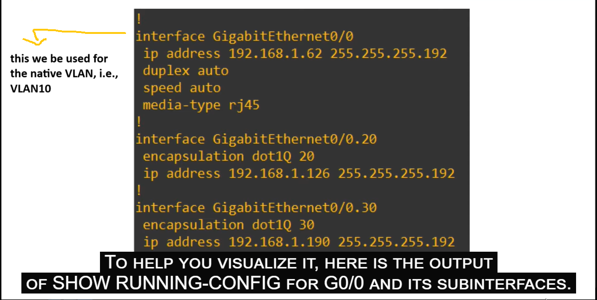

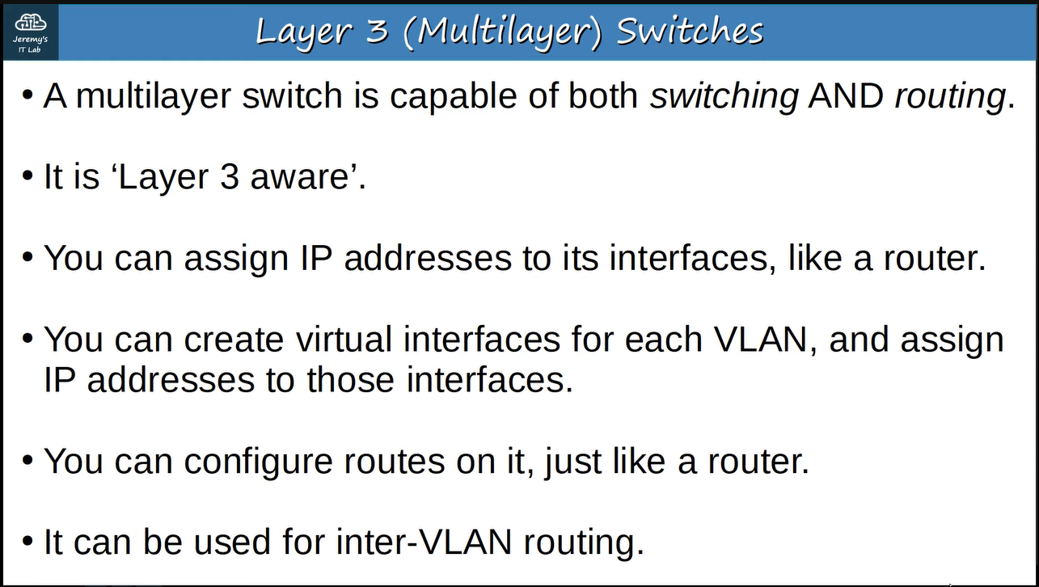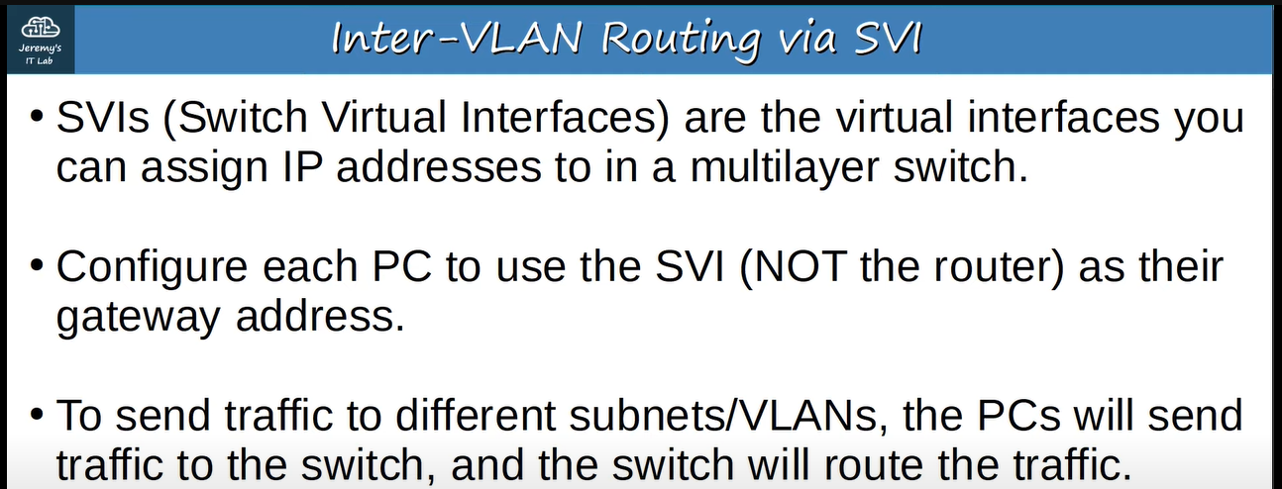

**e.g., ↓**

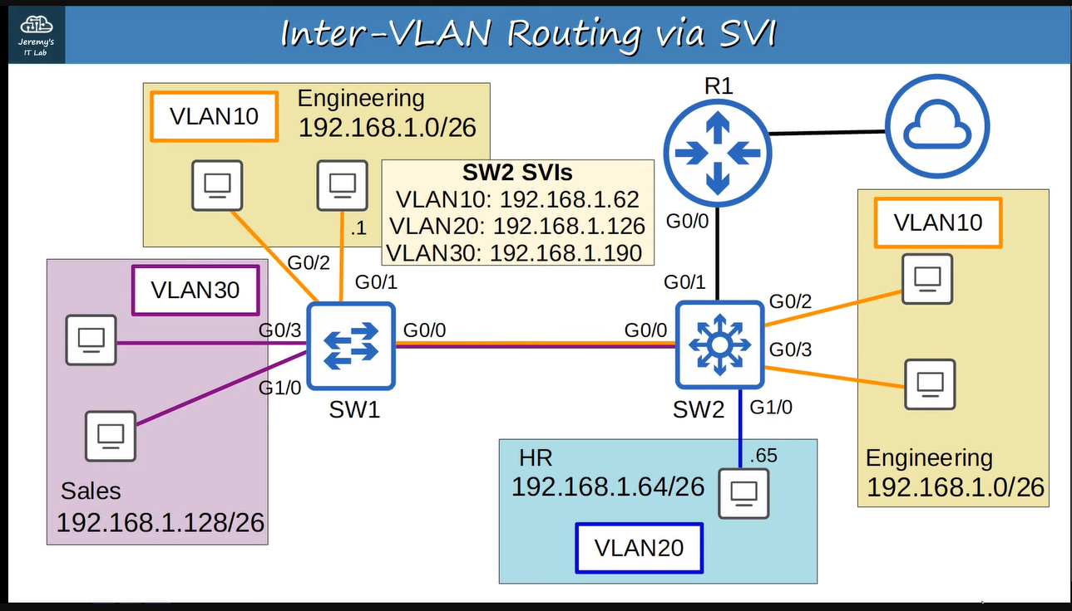

**If the host wants to send data out side of the LAN then we will assign a subnet for the point-to-point connection between SW2 & R1 then will configure a default route on SW2 pointing toward R1. So all traffic destined outside of the LAN will be sent to R1 ↓**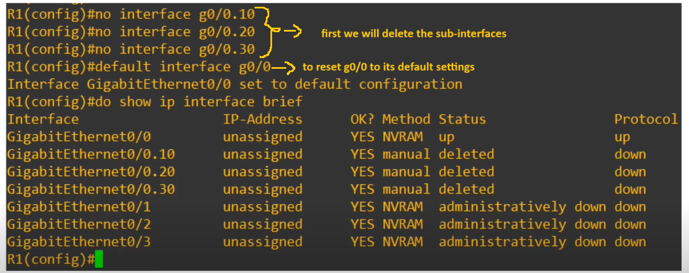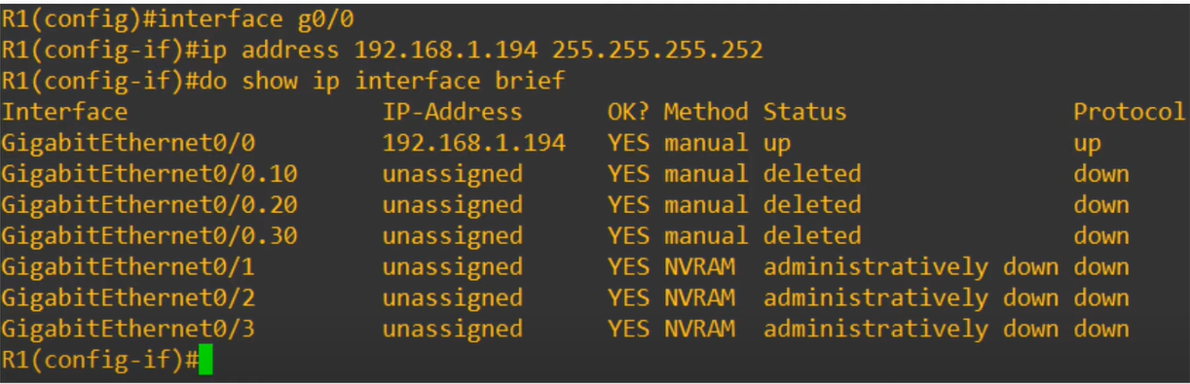

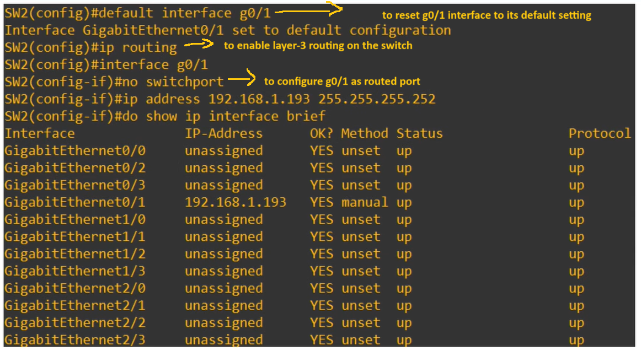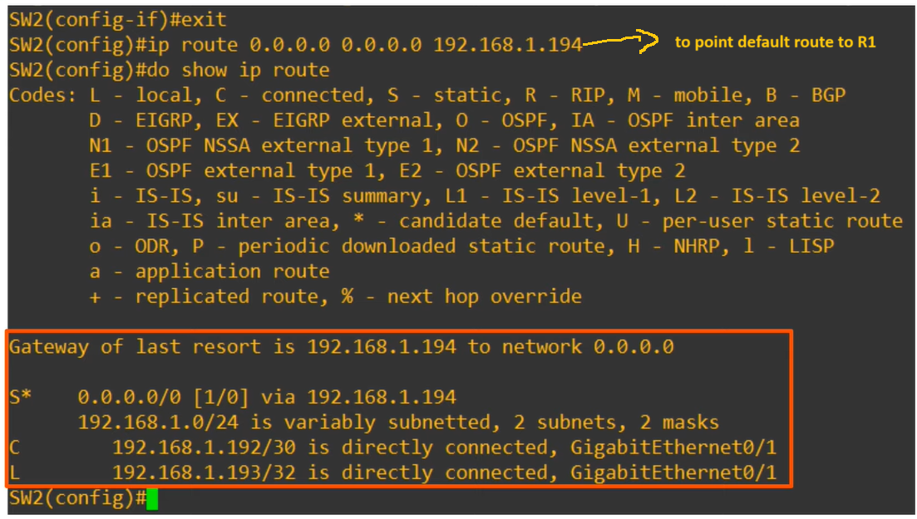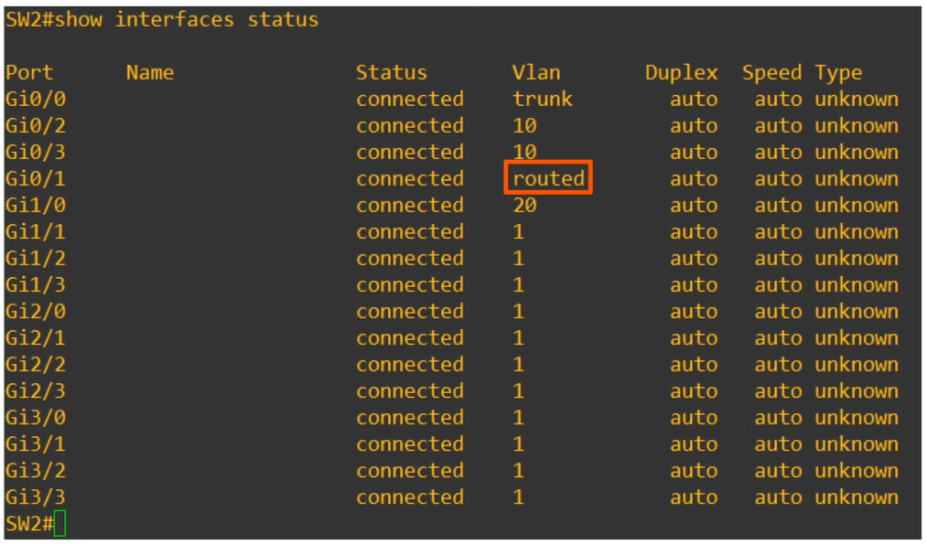

**Now we will see the configuration of SVIs ↓**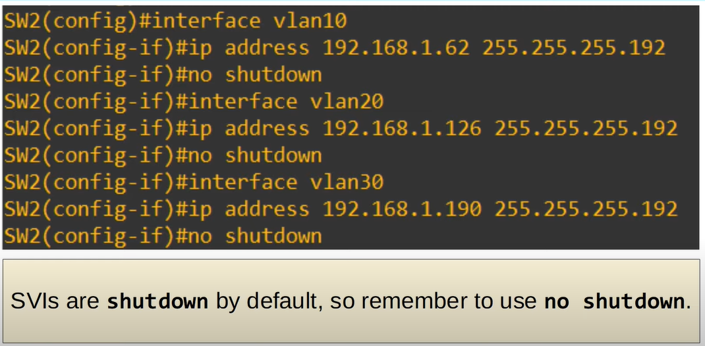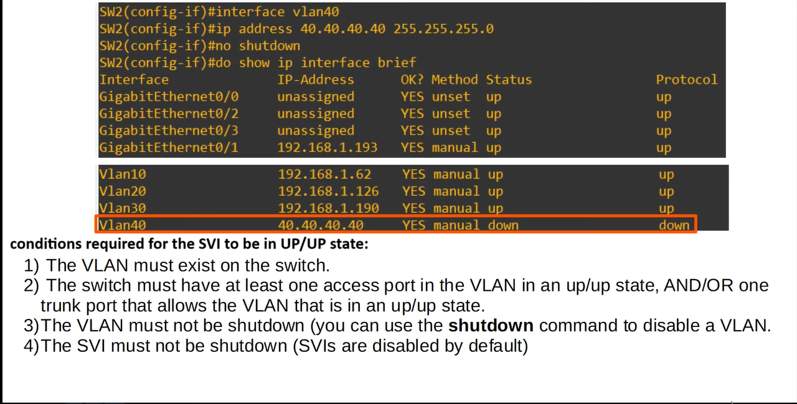

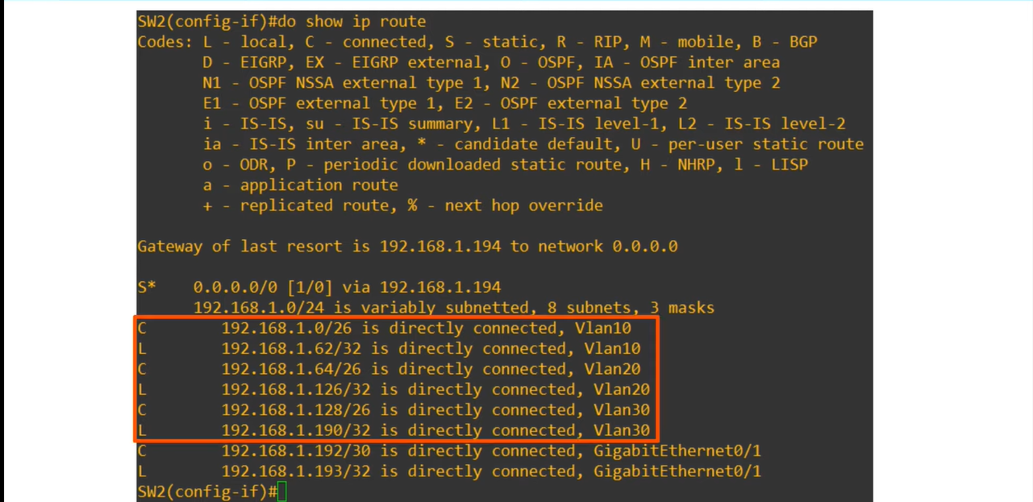

**After the configuration ↓**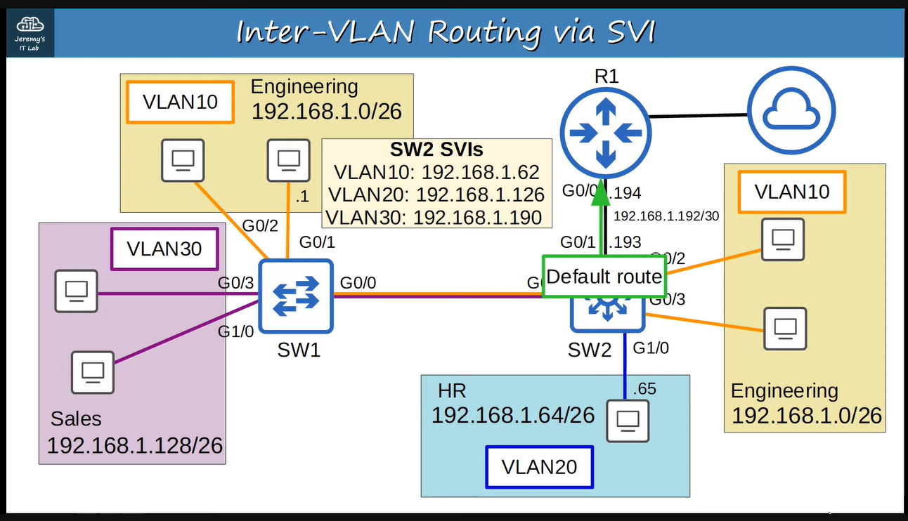

**If 192.168.1.65 wants to send data outside of the LAN ↓**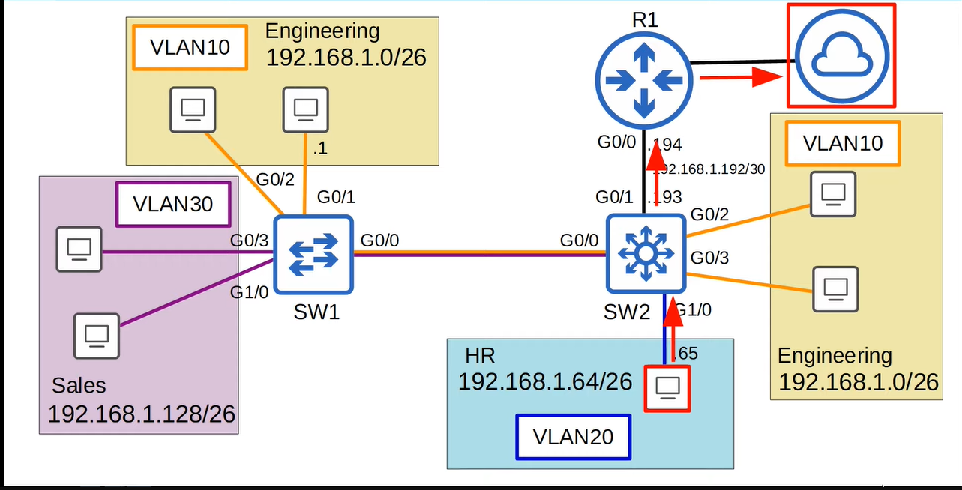

**If 192.168.1.65 wants to send data inside of the LAN ↓**